Article Title

Author One¹, Co-author One², Co-author Two³, Co-author Three⁴

¹Department of XYZ, ²Department of XYZ,
¹XYZ College, XYZ University, Name of City, Country.
²XYZ College, XYZ University, Name of City, Country.
¹ORCID ID, ²ORCID ID [if available]

Corresponding Author: Write the name of the corresponding author, E-mail:

https://doi.org/00.00000/ijdr.net00000000

ABSTRACT

Write abstract/summary of your research article here. For example:
This study explores the key themes and findings relevant to the field, providing an overview of the research scope, methodology, and principal results. The abstract briefly summarizes the context and significance of the study. Emphasis is placed on the contribution of the findings to digital research and related disciplines. Conclusions are presented, indicating implications for future studies or practice.

Keywords: Write the relevant keywords, separated by commas. For example: Digital research, Innovation, Technology, Data analysis, Digital transformation

Copyright © 2026 The Author(s). This article is licensed under CC BY 4.0. 

INTRODUCTION
Write the Introduction section of your research article here. Modify this section as applicable according to your research work. Aims/objectives of research article should be included in this section.
The introduction outlines the background of the study, emphasizing the importance of the topic within the context of modern digital developments. It identifies the research problem and the knowledge gap the study aims to address.
Add appropriate original references to the sentences/paragraphs taken from other media/sources.

LITERATURE REVIEW [if applicable, remove this section if not required]
Literature review should be written here with proper citations. This section summarizes existing research relevant to the topic. It critically evaluates prior studies and identifies trends, agreements, or debates within the literature.
The review highlights how the current study builds upon or diverges from existing knowledge. It sets the theoretical foundation for the research.
MATERIALS & METHODS
Write here the procedure/technique of your research study. This part explains the procedures and techniques used in the study. It includes details on research design, data collection, tools, and study participants (if applicable).
Any specific software, instruments, or models used are described, ensuring transparency and reproducibility. Limitations of the chosen methods may also be briefly acknowledged.

Sub-level 1

Sub-level 2

RESULTS [If applicable. Might also use “Results and Discussion” combined]
This section presents the core findings of the study in a clear and logical sequence. Data is summarized using tables, figures, or charts where appropriate.
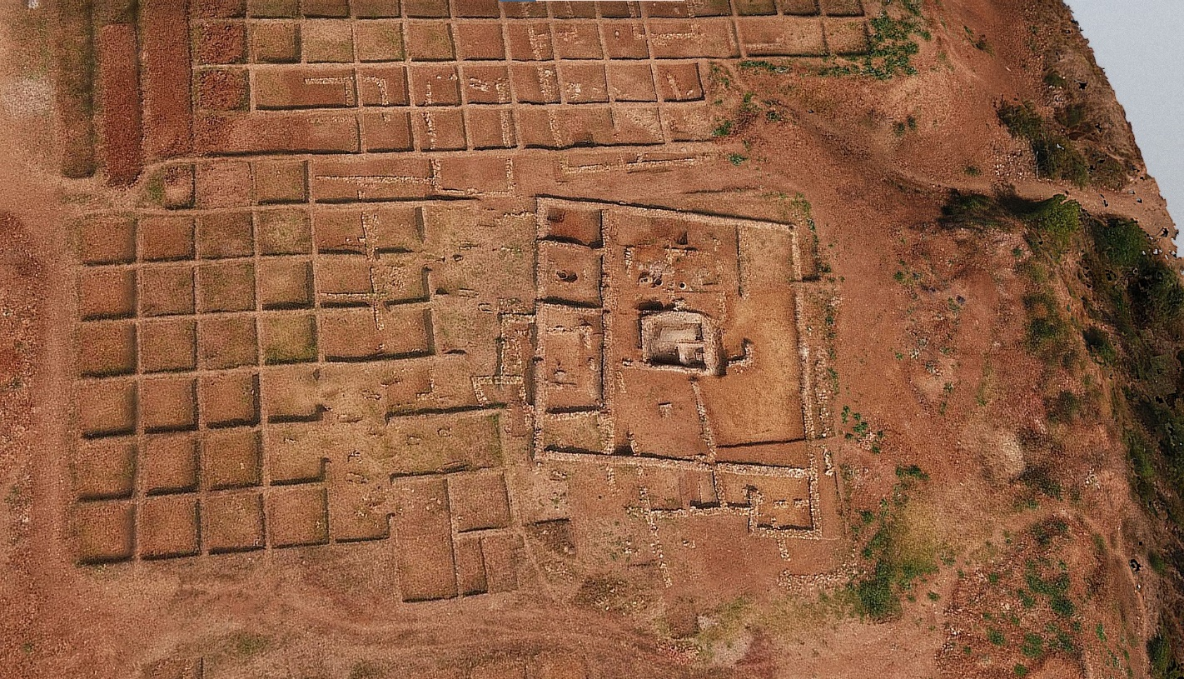
Figure 1. A detailed virtual 3D model of Skaptopara. The tomb, dated to the 3rd century AD. Source: Kristina Ilieva via Sketchfab.

Table 1. Virtual vs. Traditional Tourism: Key Metrics. Sources: MDPI, 2023; López-Sánchez & Pulido-Fernández, 2016
Metric | Traditional Tourism | Virtual Tourism
Average Satisfaction (%) | 85% | 72%
Average Cost (USD) | $2,500 | $100
Engagement Duration (Hours) | 7-14 days | 1-3 hours

Observations/Results of your study should be written in this section along with tables/charts/figures etc. Write serial numbers and appropriate heading/title of tables and legend/caption of figures.
Each key result is briefly explained, without interpretation (which comes in the Discussion). Descriptive and inferential data may both be included.

DISCUSSION
Discuss findings of your study with relevant reasoning along with proper citations/references. The discussion interprets the results in relation to the research objectives and prior literature. It highlights the importance of the findings and any unexpected outcomes.
This section may include theoretical or practical implications, limitations of the study, and suggestions for future research.

CONCLUSION
Conclude your research article here. The conclusion restates the purpose and major findings of the study. It briefly reinforces the contribution to the field.
Authors may also emphasize policy or practice recommendations, and potential directions for ongoing research based on current findings.

Declaration by Authors
Ethical Approval: Approved
Acknowledgement: None
Source of Funding: None
Conflict of Interest: The authors declare no conflict of interests.

REFERENCES
Write relevant, correct and complete references here. Use APA Style 7th Edition. For example:

Almond, G. A. (1956). Comparative political systems. The Journal of Politics, 18(3), 391–409 https://doi.org/10.2307/2127255
Bramwell, B., & Lane, B. (2011). Sustainable tourism: Emerging global challenges and regional perspectives. Journal of Sustainable Tourism, 19(4), 413-431
Karadzhov, V. (2026). How to Create the Best SOAR Analysis. International Journal of Digital Research, 2 (1): 77-89. https://doi.org/10.63711/ijdr.net20260105
Karadzhov, V. & Patarchanova, E. (2025). How to Create the Best PESTEL Analysis. International Journal of Digital Research, 1 (3): 8-20. https://doi.org/10.63711/ijdr.net20250301
Mitchell, R.E., & Eagles, P.F.J. (2021). An Integrative Approach to Tourism: Lessons from the Andes of Peru. Journal of Sustainable Tourism, 9(1), 4-28; https://doi.org/10.1080/09669580108667386
Pappas, N. (2018). Hotel decision-making during multiple crises: A chaordic perspective. Tourism Management, 68, 450-464; https://doi.org/10.1016/j.tourman.2018.04.009
Sigala, M. (2020). Tourism and COVID-19: Impacts and implications for advancing and resetting industry and research. Journal of Business Research, 117, 312–321; https://doi.org/10.1016/j.jbusres.2020.06.015

NOTE: Modify this article template as it best fits your requirements. Authors are requested to modify sections as applicable for Research Article/Review Article/Case Report/ Short Communication etc. Please delete unnecessary words from the article.

How to cite this article:
Authors’ names. (2025). Full title of article is written here. International Journal of Digital Research. E-ISSN 3033-179X, 2(2): p.p. XX-XX. https://doi.org/00.00000/ijdr.net00000000

*****

